**Marketing Management Project**

**Snackable** **launching new products**

**PROTEIN BARS & ALOE VERA JUICE**

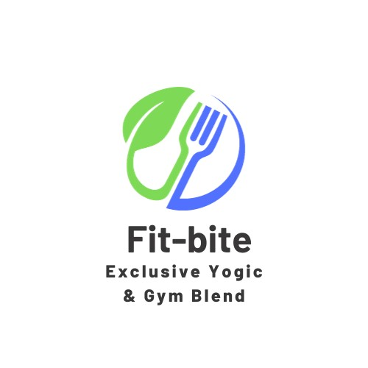

A product of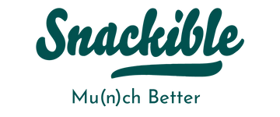

The Report submitted

by

**AVIJIT BISWAS**

Executive summary

Introduction:

Snackable for Yoga and Gym is a health-conscious snack brand dedicated to providing nutritious and delicious snack options for individuals pursuing a healthy and active lifestyle. We recognize the growing demand for convenient and wholesome snacks in the yoga and gym community.

Market Opportunity:

With yoga and fitness enthusiasts looking for healthier alternatives to typical snacks, the health and wellness sector is expanding at an exponential rate. By 2025, it is expected that the worldwide yoga and fitness market would be worth $800 billion, providing a huge market opportunity for Snackable for Yoga and Gym

Product Line:

Our product line is meticulously crafted to meet the specific nutritional needs of yoga and gym-goers. We offer a diverse range of snacks, including protein-rich bars, nutrient-packed trail mixes, low-sugar energy bites, and hydration-enhancing beverages.

Current Market Situation

* Indian Market overview: In 2022, the size of the Indian snack market was INR 38,603 Crore. Looking ahead, IMARC Group projects that the market will grow at a compound annual growth rate (CAGR) of 10.4% from 2023 to 2028, reaching INR 70,731 Crore.
* Segmentation:
  + Market Segmentation: Snackable will employ market segmentation to divide the broader consumer market into distinct segments based on common characteristics, needs, and behaviors.
  + Behavioral Segmentation: Analyzing consumer behavior, such as buying habits, usage frequency, and brand loyalty, will help determine which segments are most likely to embrace the new product.
  + Health and Dietary Preferences: Considering factors like dietary restrictions, nutritional preferences, and health-consciousness can lead to effective segmentation for health-focused snacks.
* Target Customers: Our core target group consists of active yoga practitioners, gym goers, and other fitness enthusiasts between the ages of 18 and 45. We also aim to attract working adults who are looking for quick, wholesome snack options.
* Competitor Analysis:
  + Competitor Product Analysis:
    - Patanjali: Known for manufacturing and selling products like ayurvedic medicines, herbal supplements etc.
    - Yogabar: Known for their protein bar, protein muesli, high protein oats etc.
    - Muscle Blaze: Known for whey proteins and health foods like protein muesli and oats.
  + Customer Acceptance: Comparison with one of its competitors :

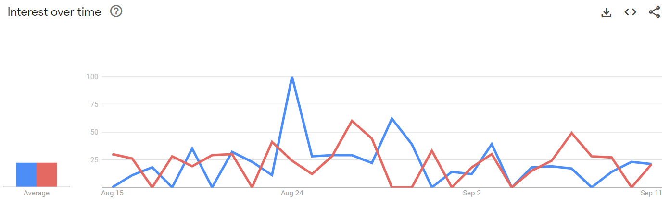

Swot Analysis

Strengths:

* Snackible's established brand reputation and recognition
* The company has a well-developed distribution network, ensuring efficient product availability in various markets.

Weaknesses: Snackible may face potential internal challenges related to resource allocation and budget constraints for marketing and product development.

Opportunities: The growing trend towards healthier snacking options presents an opportunity for Snackable to introduce a product that caters to health-conscious consumers.

Threats: Intense competition in the snacking industry from both established players and emerging brands may create pricing pressures and market saturation. Fluctuations in commodity prices and supply chain disruptions can impact production costs and product availability.

Market Objective

* Increase of sales
  + Sales Promotion: Snackible can kickstart sales by offering limited-time promotions and discounts to entice early adopters and price-sensitive consumers.
  + Cross-Promotions: Collaborate with other complementary brands to create bundled offerings or joint promotions, encouraging cross-sales and expanding the customer base.
* Build brand awareness
  + Content Marketing: Our content strategy will include creating informative and entertaining content that not only highlights our product but also educates consumers about the broader snacking culture and trends.
  + Sponsorships and Events: Snackible will sponsor relevant events or host its own, both in-person and virtual, to showcase the product and engage with potential customers directly.
* Marketing strategy
  + Product Differentiation: Snackible's new product will emphasize its unique features and benefits, setting it apart from competitors. Whether it's a distinctive flavor, health benefits, we'll highlight what makes it special.
  + Social Media Advertising: Utilizing platforms like Facebook, Instagram, and Twitter, we'll run targeted advertising campaigns to reach our audience.

Ansoff matrix:

This matrix represents that our product is currently at the product development stage.

|  |  |  |
| --- | --- | --- |
|  | Existing Market | New Market |
| Existing Product | Market Penetration | Market Development |
| New Product | **Product Development** | Diversification Strategy |

Positioning

Positioning Statement:

* For Protein Bars (Gym Enthusiasts): "Want a snack, but not your cheat day yet? At Snackible, we've crafted the ultimate snack for Gym Enthusiasts - our protein bars.”
* For Aloe Juice (Yoga Practitioners): "At Snackible, our Aloe Juice is your trusted companion on your yoga journey. “

Value Proposition:

* For Protein bars:
  + High-Quality Protein and good taste: Our protein bars pack a potent protein punch that helps muscles grow and repair after challenging workouts. Ditch the tasteless, chalky protein bars.
* For Aloe juice:
  + Pure Aloe Vera and Hydration: Our aloe juice is produced using only pure aloe vera, which is well-known for its relaxing and restorative effects and is perfect for yoga practitioners. Aloe juice naturally keeps you hydrated.

4Ps:

* Protein bars:
  + Product: Snackible’s protein bars are intended for fitness enthusiasts. They are delicious, made using premium protein sources, and packed for easy consumption while traveling.
  + Price: Snackible has set its protein bars at a fair price so that gym enthusiasts may get value for their money. Pricing is chosen such that it reflects the value and quality of the product while still being affordable to the target market.
  + Location: Our online store, gyms, fitness centers, and health stores will all carry these protein bars as part of our distribution strategy
  + Promotion: Snackible's promotional activities include social media marketing campaigns that target gym enthusiasts, fitness publications, and partnerships with fitness influencers.
* Aloe juice:
  + Product: Aloe juice from Snackible is marketed to yoga practitioners as being natural and pure. Price: Aloe Juice is priced competitively while still reflecting the excellent quality and advantages it provides to yoga practitioners.
  + Location: Our online store, a few health stores, yoga studios, and wellness centers all carry the product.
  + Promotion: Snackible uses marketing strategies that connect with yoga practitioners to sell its aloe juice. The promotion will be done through partnerships with yoga instructors, wellness events, and online content.

Control

A control strategy is a plan of action that is designed to manage and mitigate risks or potential problems that may arise in the production, distribution, or promotion of an energy drink.

**Marketing control: -**

1. Survey

2. Feedback

3. Product performance review

Budget

|  |  |
| --- | --- |
| **Categories** | **Cost** |
| Market Research | 40000 |
| Production cost(PPE)  -Gym product  -Yoga product | 500*0.6*1000=300000  180*0.4*1000=200000 |
| Advertisement and Promotion | 100000 |
| Distribution | 1,70,000 |
| Others(fixed cost) | 1,00,000 |
| Total | 9,10,000 |

*Per month cost*

Break even = 727 units of product

Research tools, References and Exhibits

*Exhibit 1. Google searches of last 3 months (jun 23’-sep 23’)for a comparison of Gym food and yogic/ayurvedic food.*

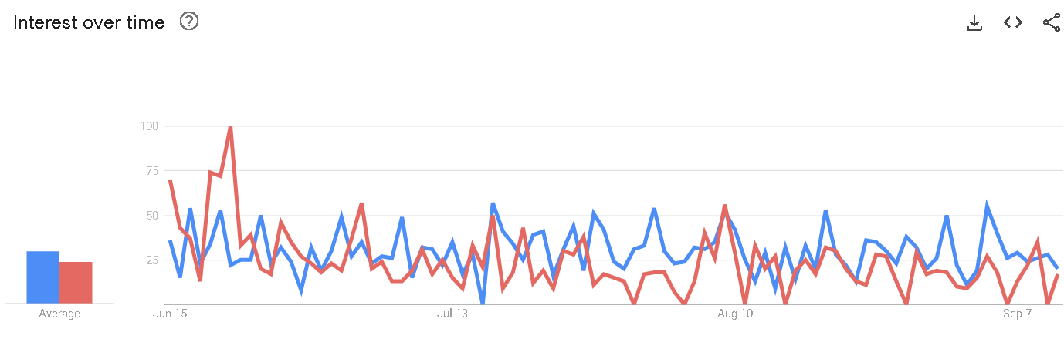

== - Gym foods  = =-Yogic/ayurvedic foods

Research Tools:

1)[Google Trends](https://trends.google.com/trends/)

2)[Search listening tool for market, customer & content research - AnswerThePublic](https://answerthepublic.com/)

3)https://ads.google.com/intl/en_in/home/tools/keyword-planner/

References:

1)[All Snacks (snackible.com)](https://www.snackible.com/collections/our-snacks)

2)[20 Tools & Resources for Conducting Market Research (hubspot.com)](https://blog.hubspot.com/marketing/market-research-tools-resources)